Assignment-4

Assignment 4: Write a script that creates a directory named TestDir and inside it, creates ten files named File1.txt, File2.txt, ... File10.txt. Each file should contain its filename as its content (e.g., File1.txt contains "File1.txt").

Shell script code with the name of create_files.sh:
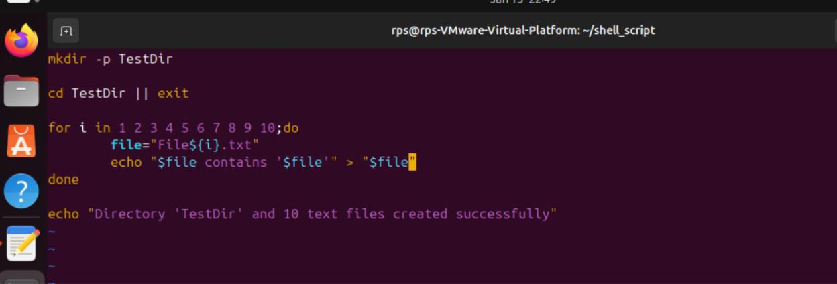

Commands to run create_lines.sh and checking its function:
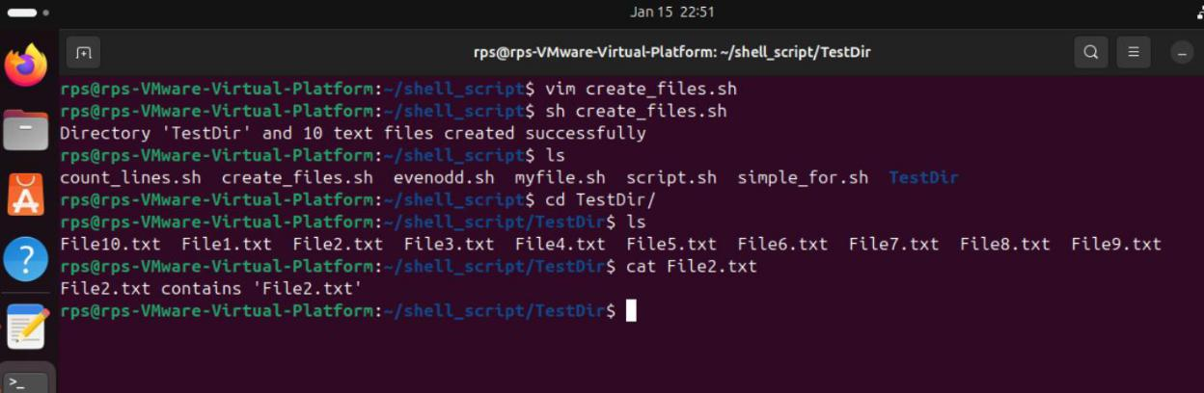

21958-Lokesh_Panem

